Day 1: Promote Quiz:  Five Days of Action Social Media Graphic Pictures & Template Copy:  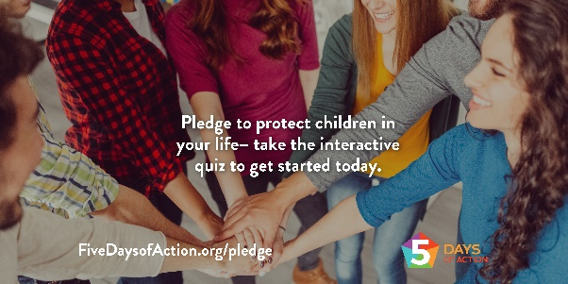 | Jump into action by taking this interactive quiz and signing the pledge to protect card and sign to show you’re ready protect the kids in our community. Visit https://www.fivedaysofaction.org/pledge to get started! #FiveDaysofAction
Day 1: Five Days of Action Kick-Off:  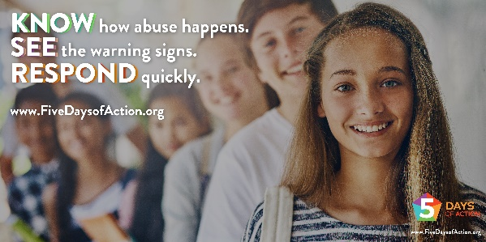 | Join in on the Five Days of Action and help create a safer world for children with the three habits of sexual abuse prevention - KNOW. SEE. RESPOND. Head over to www.FiveDaysofAction.org/pledge to sign the pledge & learn more. #FiveDaysofAction.
Day 2: KNOW Graphic 1:  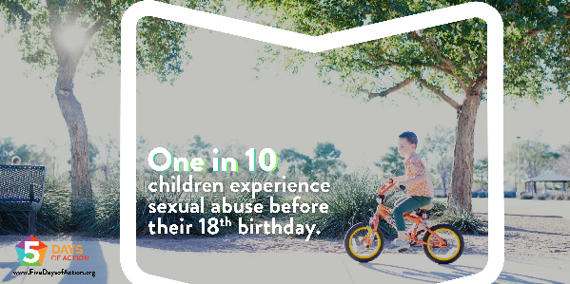 | KNOWing the facts about child sexual abuse can help you better understand what to look for and how to prevent abuse. Learn more at www.FiveDaysofAction.org. #FiveDaysofAction
Day 2: KNOW Graphic 2:  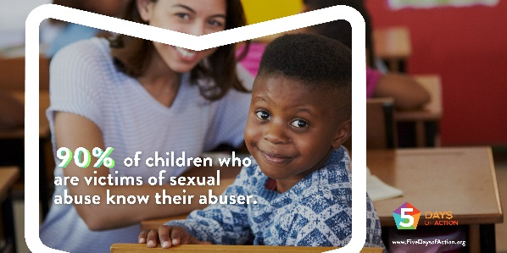 | People who abuse children often become friendly with the potential victims and their families. They participate in family activities, earn trust, and gain alone time with children. Learn more at www.FiveDaysofAction.org #FiveDaysofAction
Day 2: KNOW Graphic 3:  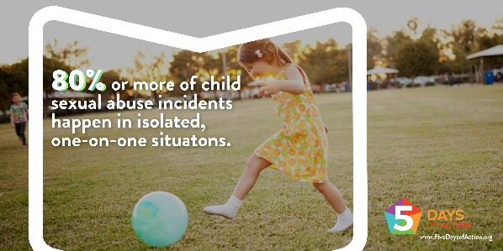 | When looking at youth-serving organizations, ask for a copy of their protection policy. It should include how they limit isolated one-on-one situations. If it doesn’t, consider this a red flag. Visit www.FiveDaysofAction.org to learn more. #FiveDaysofAction
Day 3: SEE Graphic 1:  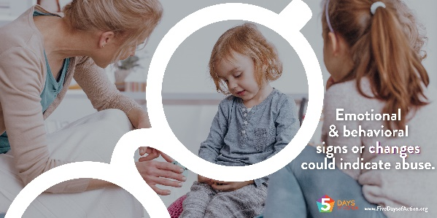 | Signs that a child is being sexually abused are often present, but they can be indistinguishable from other signs of child stress or trauma. Learn more signs at www.FiveDaysofAction.org. #FiveDaysofAction
Day 3: SEE Graphic 2:  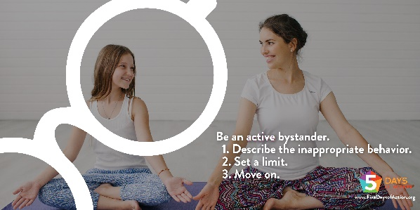 | Offenders are often seen breaking rules and pressing boundaries. When we SEE boundaries being crossed, we must be an active bystander & take risks and stand up to other adults. Learn more about bystander intervention in the KNOW. SEE. RESPOND. booklet at www.FiveDaysofAction.org.  #FiveDaysofAction
Day 3: SEE Graphic 3:  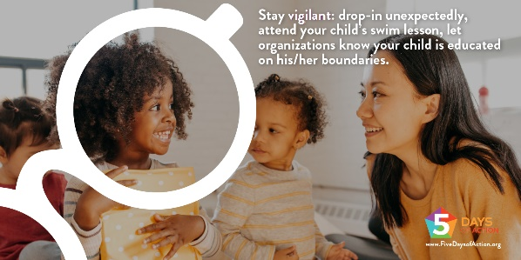 | People who abuse children often become friendly with the potential victims and their families. Being vigilant lets the adults in your child’s life know that you are watching. See more examples at www.FiveDaysofActoin.com #FiveDaysofAction
Day 4: RESPOND Graphic 1:  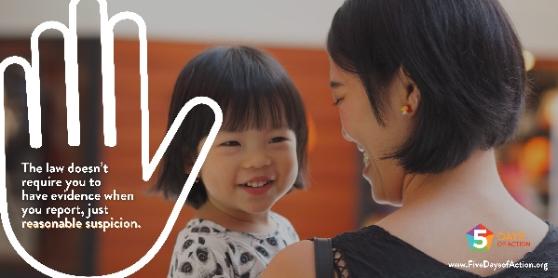 | Offenders are rarely caught in the act of abusing a child, but they’re often seen breaking the rules and pressing boundaries.  If you suspect abuse, RESPOND by reporting it. Find more reporting tips at www.FiveDaysofAction.org. #FiveDaysofAction
Day 4: RESPOND Graphic 2:  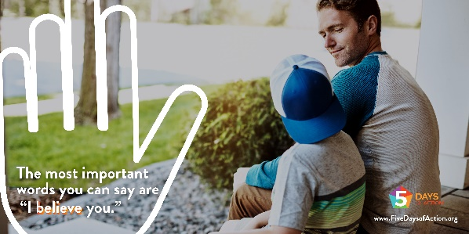 | Only 4 to 8% of child sexual abuse reports are false. The most important action you can take is to believe a child who discloses and report to the appropriate authorities. Find some simple responses that are supportive at www.FiveDaysofAction.org. #FiveDaysofAction
Day 4: RESPOND Graphic 3:  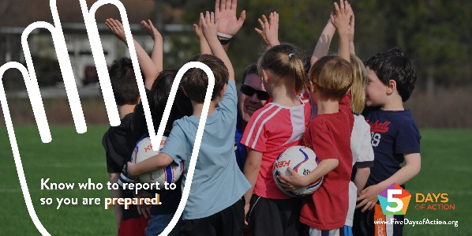 | When it comes to reporting abuse, it can be intimidating but it doesn’t have to be! If you are prepared, you will know exactly when and how to RESPOND. In our area, call [AGENCY] at XXX-XXX-XXXX.  www.FiveDaysofAction.org. #FiveDaysofAction
Day 5: Wrap Up Graphic 1:  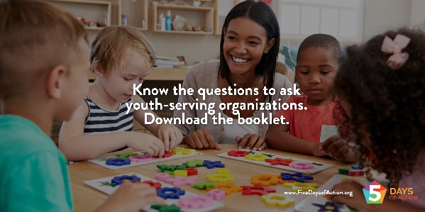 | Between soccer practice, tutoring sessions, and piano lessons, your child is frequently in the care of many different adults. How do you keep them safe? Check out the KNOW. SEE. RESPOND. booklet for some proactive questions you can ask youth-serving organizations. www.FiveDaysofAction.org #FiveDaysofAction
Day 5: Wrap Up Graphic 2:  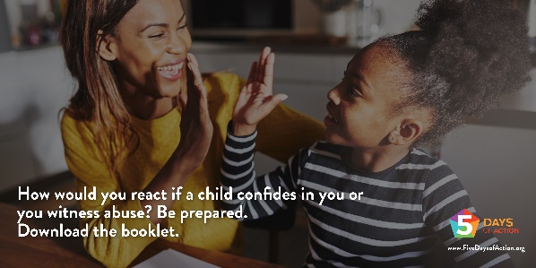 | A child who discloses abuse has taken a huge risk in telling you. Give attention, compassion, and belief. Be prepared to act. Learn more at www.FiveDaysofAction.org. #FiveDaysofAction

